ShopNest Power BI Capstone Report

# 1. Top Categories by Total Price

Identify and visually represent the top 10 product categories by total sales.

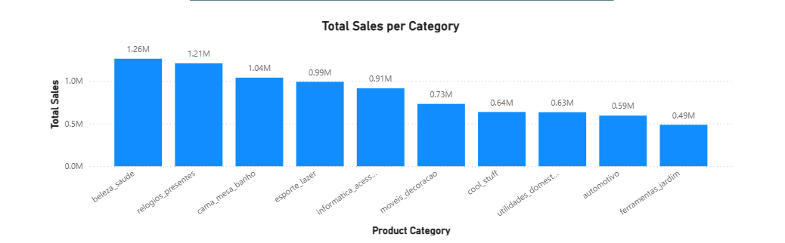This bar chart shows the top 10 product categories based on total sales. It helps identify which categories contribute the most revenue.

# 2. Delayed Orders Analysis

Determine the number of delayed orders in each category.

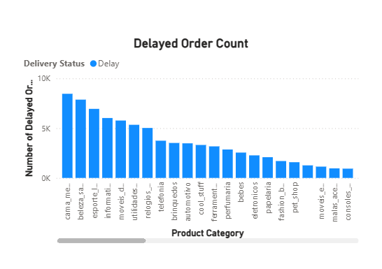

The chart displays the count of delayed orders across different categories, highlighting areas where delivery performance needs improvement.

# 3. Monthly Comparison of Delayed and On-Time Orders

Compare the number of delayed orders to the number of on-time orders each month.

v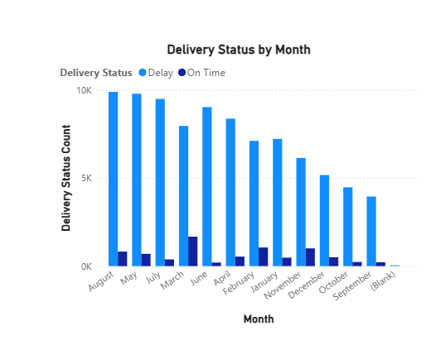

This stacked column chart compares delayed and on-time orders month by month, offering insights into seasonal delivery trends.

# 4. Payment Method Analysis

Analyze the most frequently used payment methods by customers.

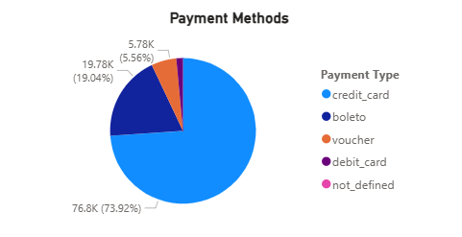

The pie chart illustrates the distribution of payment methods used by customers, indicating customer payment preferences.

# 5. Product Rating Analysis

Determine the top 10 highest-rated and bottom 10 lowest-rated products.

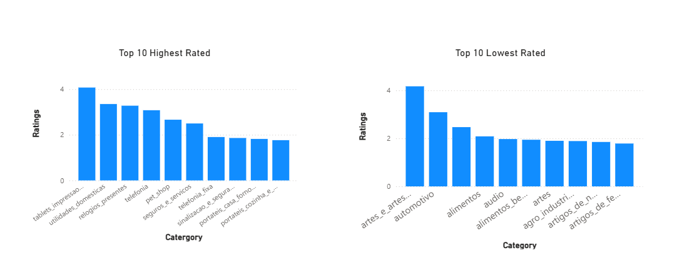

Two bar charts show the highest and lowest-rated products based on customer ratings, useful for product improvement and marketing.

# 6. State-wise Sales Analysis

Identify and visually represent states with high and low sales.

MAP DID NOT WORK

The map/bar chart shows regional performance by state, revealing high and low-performing regions in terms of sales.

# 7. Seasonal Sales Patterns

Investigate and visualize seasonal patterns in sales data quarterly.

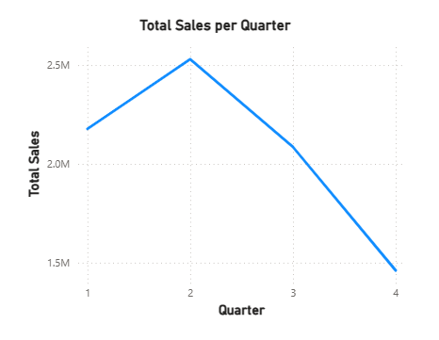

This quarterly analysis shows sales trends across different seasons, helping with planning and inventory management.

# 8. Revenue Analysis

Determine total revenue generated and analyze its changes over time (yearly).

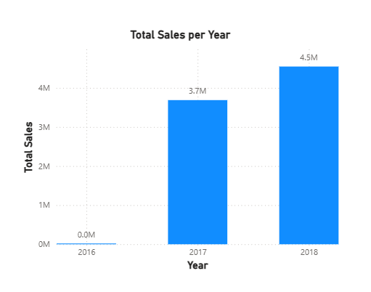

The line chart displays the yearly revenue trends, offering a clear view of ShopNest’s growth and financial performance over time.